USAID Environmental Impact Assessment Tool
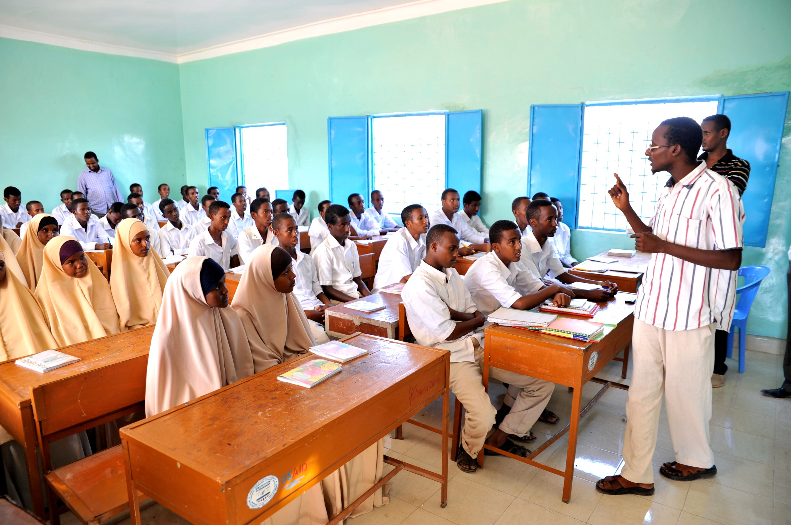

December 2017
This document was produced for the United States Agency for International Development (USAID).

Front Cover: USAID newly constructed classroom. Abdulaziz Bashir/USAID
In Somalia, SYLI aims to meet the high demand for education and provide a safe space for youth to learn and acquire life skills. Across all regions of Somalia, SYLI provides an array of opportunities to youth, including Formal and Non-Formal Education that promotes literacy and numeracy, skills training and entrepreneurship that builds economic survival, leadership and conflict resolution training that strengthens civic participation and social cohesion. Throughout these efforts, SYLI promotes equal participation of boys and girls. SYLI also develops the capacity of Ministry of Education officials to provide fair, equitable, and quality education services to Somali youth through construction of schools, training of teachers, provision of teaching and learning materials, and develops the capacity of local Community Education Committees to sustain these investments.

Introduction
USAID procedures require that the potential adverse impacts of USAID-funded and managed actions be assessed prior to implementation via the Environmental Impact Assessment (EIA) process defined by 22 CFR 216 (Reg. 216). Consistent with 22 CFR 216, the U.S. National Environmental Policy Act and the Council on Environmental Quality implementing regulations, the project team must consider direct, indirect, and cumulative impacts on the environment, natural resources, public health, and indigenous peoples. EIAs must include the assessment of associated facilities and alternatives to the proposed project. USAID environmental procedures also require that the environmental management and mitigation measures (“conditions”) identified by this process be written into award documents, implemented over the life of project, and monitored for compliance and sufficiency.
The procedures are USAID’s principal mechanism for environmental and social impact assessment of USAID-funded activities; and thus, for protecting environmental resources, ecosystems, and the health and livelihoods of beneficiaries and other groups. They strengthen development outcomes and help safeguard the good name and reputation of USAID.
This EIA Tool is intended to assist in evaluation of potential impacts of proposed USAID projects. It complements the Sector Environmental Guidelines (SEGs) (http://www.usaidgems.org/sectorGuidelines.htm), which provide information essential for assessing the potential impacts of actions and for identifying and designing appropriate mitigation and monitoring measures.

Purpose
This document is intended to assist design teams during strategy, project, or activity-level design and analysis of environmental and social impacts, as well as during development of mitigation measures. The EIA Tool helps users identify such impacts and directs users to additional information about how best to minimize those impacts. Using this tool early in the planning process will help all USAID staff and IPs avoid adverse environmental and social impacts and build mitigation measures into their project/activity designs.
This EIA Tool serves as one resource available to Agency staff, including Mission Environmental Officers (MEOs), Bureau Environmental Officers (BEOs), Regional Environmental Advisors (REAs), Contracting Officer’s Representatives (CORs), and Agreement Officer’s Representatives (AORs), as well as Implementing Partners (IPs), that can be used at all phases of the project cycle, including the design phase, for conducting the impact analysis, and while preparing environmental compliance documentation. This tool is not intended to act as a complete summary of all potential impacts, as site-specific context is critical to determining those impacts. Furthermore, the tool is not a substitute for detailed sources of technical information or design manuals. Users are expected to seek out appropriate resources for additional information related to the proposed action.

Overview
This tool has seven steps, shown below and illustrated in Figure 1:
- Define the project/activity and the applicable sectors and sub-sectors
- Apply the checklist (Annex I)
- Determine eligibility for a Categorical Exclusion (Annex II)
- Use the Matrix for Identifying Appropriate SEGs based on Project/Activity Sector(s) and Impacts (Annex III)
- Revise project design (as needed/if applicable)
- Document the analysis in a Reg. 216 document
- Develop Environmental Mitigation and Monitoring Plan (EMMP)

These steps are described in their respective sections further below.
As illustrated in Figure 1, below, this checklist should be used after determining the nature of a potential action. An action need not be fully designed at the time the checklist is used, and the checklist may, in fact, serve to help refine or adjust certain aspects of the original design. Based on the relevant sectors (and sub-sectors) of the action, the user can simultaneously begin to consider applicable USAID SEGs, which identify typical potential environmental and social impacts associated with a sector, and start completing the checklist to identify the resources that may be impacted.
Step 6
Is the Action Eligible for a Categorical Exclusion?
Step 5
Step 4
Step 3
Step 2
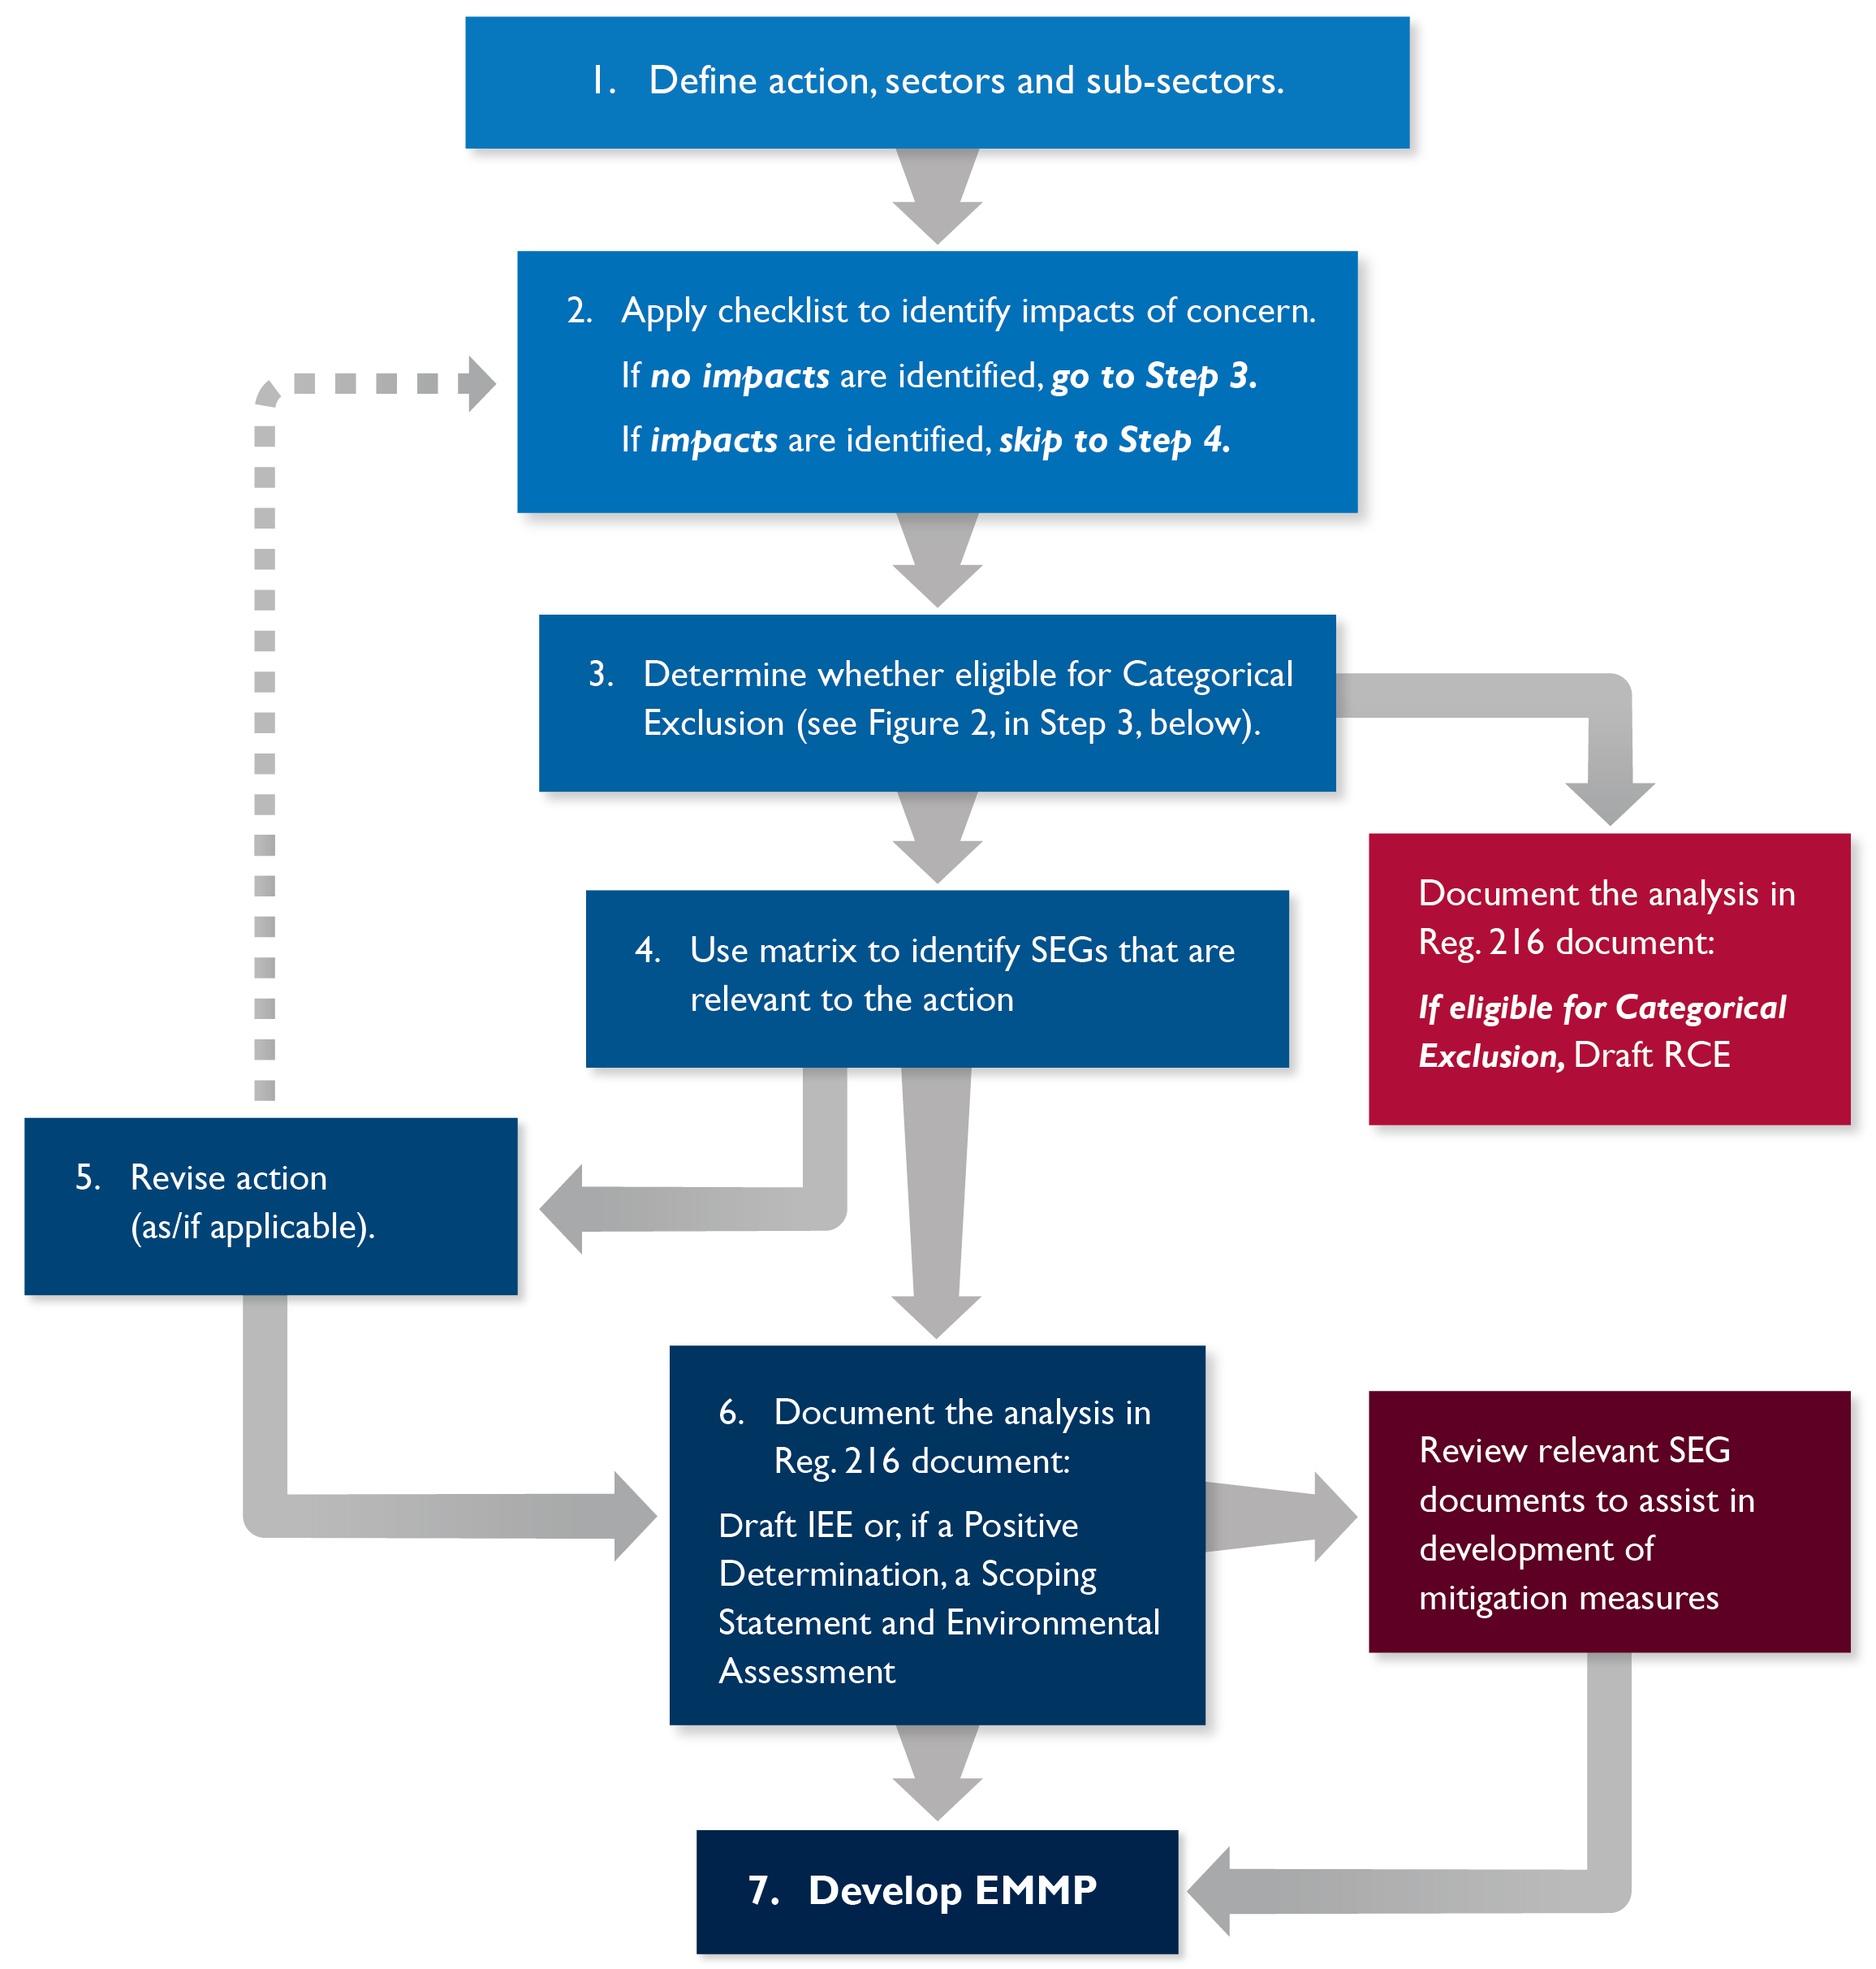
Figure 1. Work flow process for use of EIA Checklist and Matrix

RCE: Request for Categorical Exclusion
Step 1
IEE: Initial Environmental Examination

Step 1: Define the action and the applicable sectors and sub-sectors.
The first step requires definition of the action, in terms of planned objectives and components, as well as the sectors and sub-sectors of the activity. Annex V includes a form that can be used to help define all the component actions of the action.

Step 2: Apply the EIA Checklist
The checklist (Annex 1) should be used to consider potential impacts that may result from an action, as well as the potentially impacted resources. The checklist can help the team identify any additional information that may still be needed to establish a baseline condition and to properly evaluate potentially impacted resources.

Step 3: Determine eligibility for a Categorical Exclusion
22 CFR 216.2(c) defines the types of activities eligible for Categorical Exclusion (Annex II). Figure 2, below, illustrates the decision tree for determining whether a action is eligible and appropriate for Categorical Exclusion. Annex II describes activities eligible for a Categorical Exclusion. The checklist is not mandatory for projects or activities that meet the criteria for an exclusion; however, use of the checklist is suggested to identify and address potential environmental and social impacts.

Step 4: Use the Matrix to identify relevant SEGs
Once the relevant sectors and sub-sectors for the action have been determined and potential impacts of concern have been identified, the action design team should use the Matrix for Identifying Appropriate SEGs Based on Sector(s) and Impacts (Annex III). The matrix maps project/activity sectors and sub-sectors to types of impact, guiding the user to the USAID SEGs (Annex IV) that will provide the most applicable information for addressing impacts for a sector.

Step 5: Revise project design (as/if applicable)
Based on the findings from the checklist and consideration of relevant SEGs and other best practice references, the user may determine it most effective to modify the design to avoid, eliminate, or reduce potential impacts, rather than proceed further. If the determination is made to revise the design of the action, that should be done at this stage, with changes carried through to all relevant documents (e.g., the Project Appraisal Document (PAD), Activity Appraisal Document (AAD), and Initial Environmental Examination (IEE)).

Step 6: Document the analysis in a Regulation 216 document
Once the action’s design has been finalized, the information gathered through the checklist and SEG process will assist the project design team in performing the analysis required for Reg. 216 documentation (templates for these documents are available at https://sites.google.com/a/usaid.gov/reg-216-templates/). This documentation must be submitted for review and approval by, at minimum, the applicable Mission Director and BEO.

Step 7: Develop EMMP
Prior to initiating any actions for which implementation conditions were established to address potential environmental or social impacts, the IP must develop an EMMP. In preparing the EMMP, the IP should refer again to the relevant SEGs to assist in identification of effective mitigation and monitoring measures for the potential impacts of the action.
Figure 2. Decision Tree for Categorical Exclusions

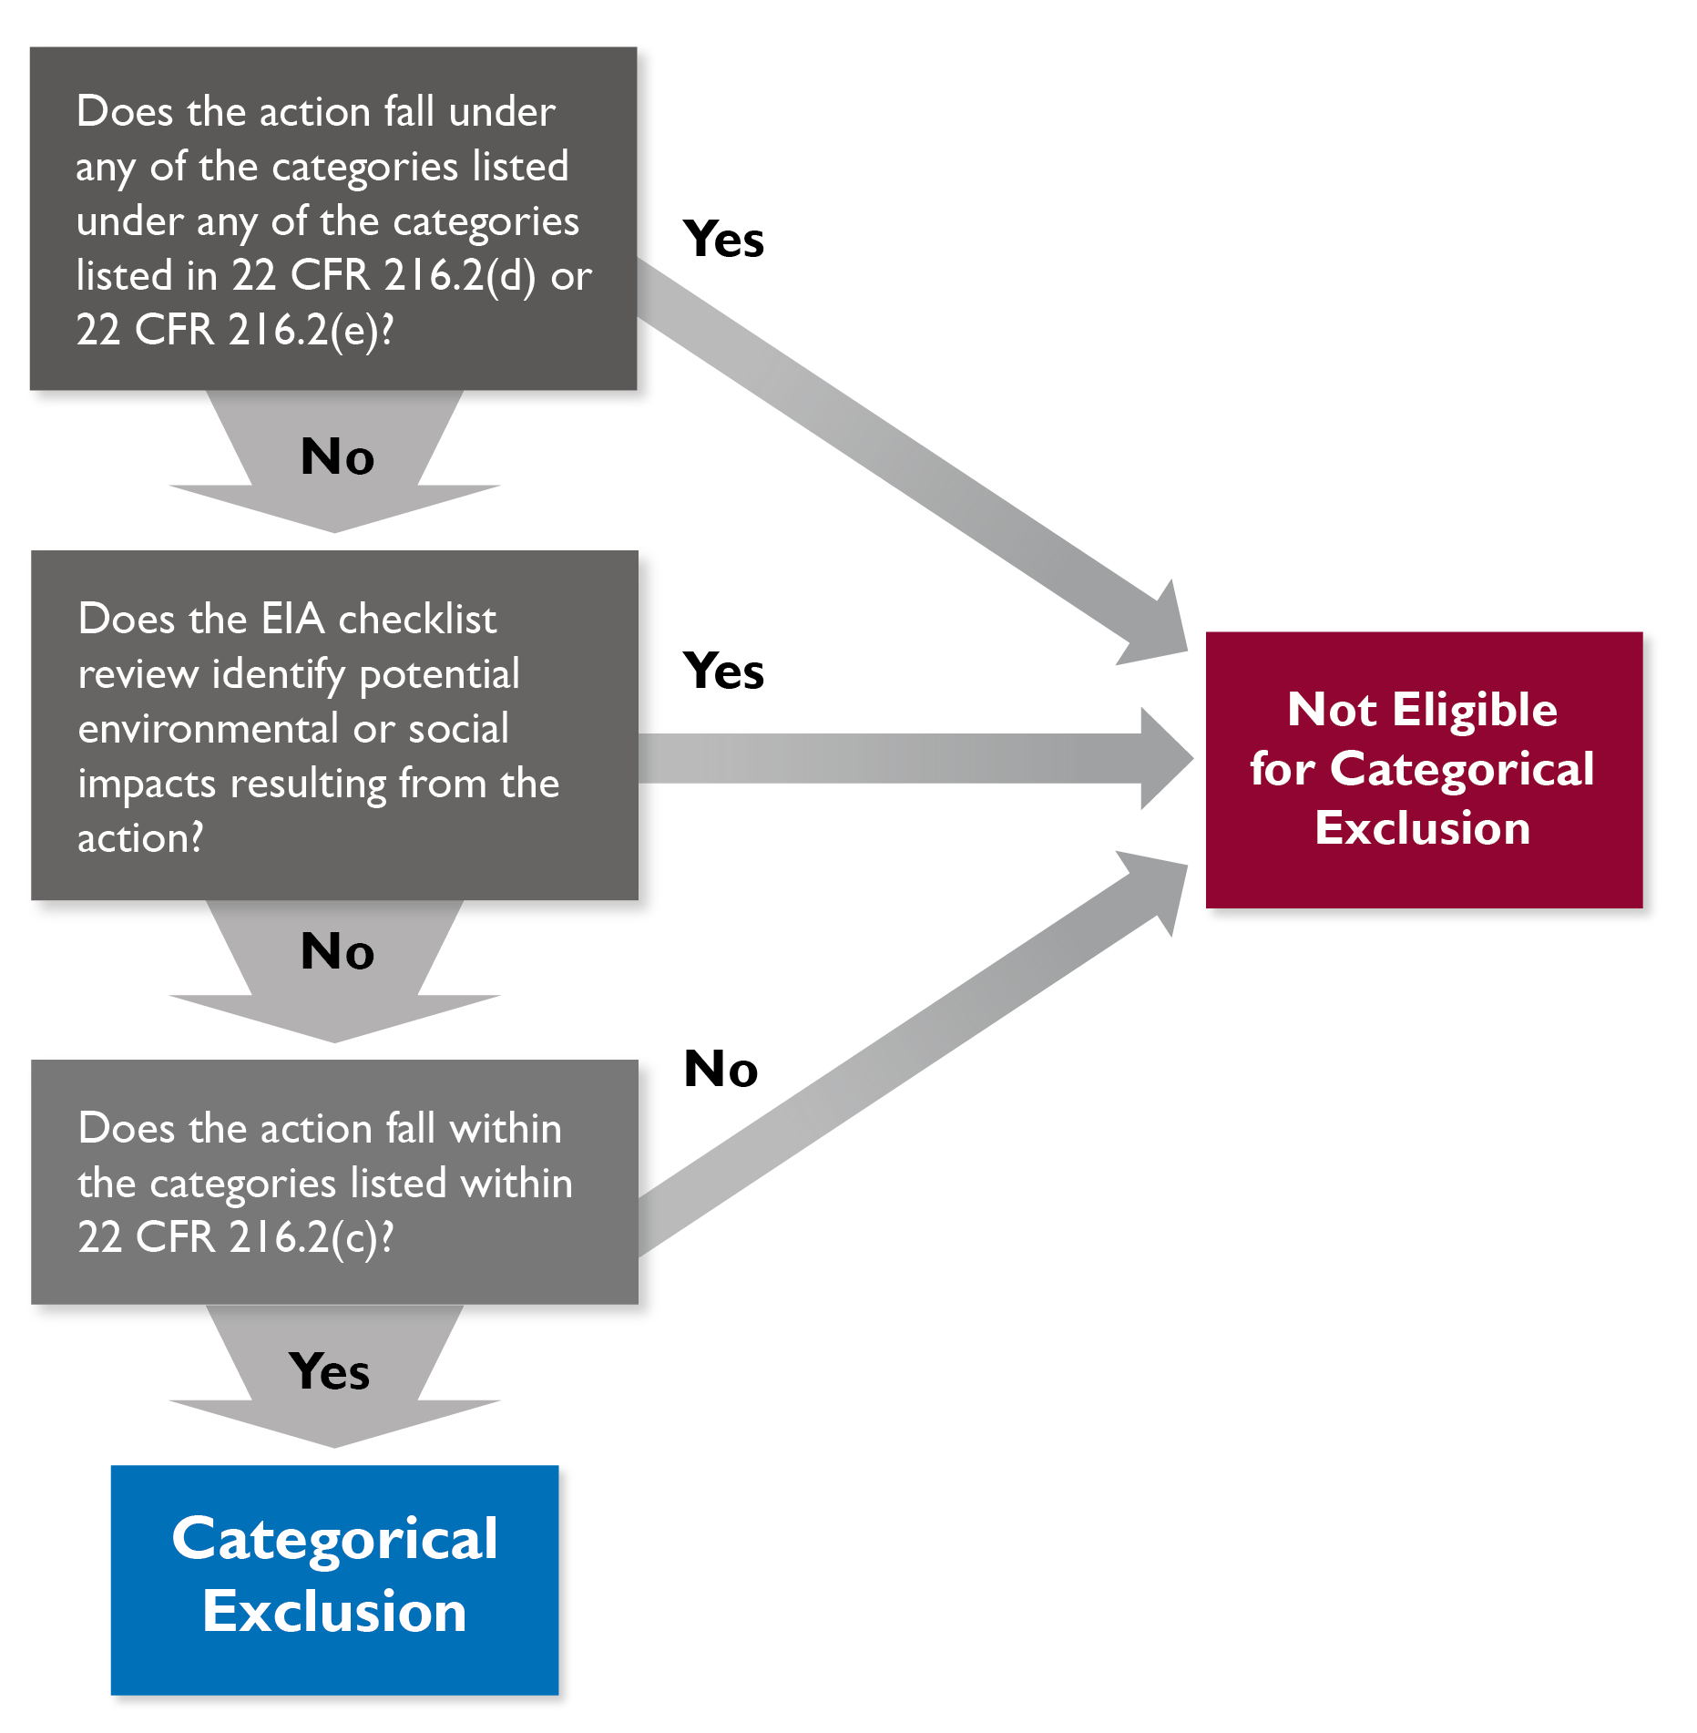

Annex I – The EIA Checklist

Checklist Instructions
Please answer each question first with a mark in the “yes,” “no,” or “don’t know” column. If the answer is “yes,” please provide an explanation of how and why your actions may cause the associated impact(s) as well as answers and explanations for additional questions if applicable.
If the answer is “no” or “don’t know,” please justify or elaborate, and provide any details about the activities that may be relevant. Links to the data used to answer these questions will be useful during the documentation step. When the checklist is completed, please place a copy in the project approval file. As appropriate, submit for review to the MEO/REA/BEO, or if applicable, as an annex to the PAD/Activity Approval Memo.
General Implementation and Monitoring Requirements
- Provide briefings for IP on environmental compliance responsibilities
- Ensure integration of compliance responsibilities in prime and sub-awards and grant agreements
- Ensure compliance with applicable partner country requirements
- Annual review of project activities to ensure that scope is still covered by Categorical Exclusion

Project Title:
Completed By: DATE:
Question | Yes | No | Don’t know | Explanation and/or response to additional question if applicable
AIR
- Will actions increase or decrease emission of air pollutants, e.g., soot, sulfur dioxide, oxides of nitrogen, volatile organic compounds, methane?
For example, from combustion of materials for energy or manufacturing.
- Will actions involve burning of wood or biomass?
For example, for heating or waste disposal.
- Will actions include installation, operation, maintenance, or decommissioning of systems containing ozone-depleting substances?
For example, the installation, use, or disposal of equipment using Freon or other refrigerants.
- Will actions generate an increase in carbon emissions?
For example, combustion of fuel for energy generation.
- Will actions generate an increase in the amount of suspended particulate matter in the air?
For example, soot, dust or smoke.
- Will actions cause impacts (positive or negative) on public health or well-being?
- Will actions have a disproportionate impact on one gender versus another?
Surface Water Quality and Quantity
- Will actions provide a new source of drinking water for a community? |  |  |  | If yes:  How will the IP monitor water quality in accordance with health standards?
- Is the project/activity site located near a waterbody?  For example, within 50 meters of a lake/pond, river/stream, wetland, riparian area, or ocean. |  |  |  | If yes:  Is it upstream/downstream?
- What type of water is close to the site?
For example, lake, stream, wetland, ocean
- Will actions have the potential to impact:  - Drinking water supplies of humans, animals, or plants?  - Water supply sources for irrigation? |  |  |  | For example, via the  - extraction of surface water.  - runoff of pesticides, fertilizers, or toxic chemicals.  - discharge of domestic or industrial sewage.  - increased volume of storm water run-off and/or potential for discharge of potentially contaminated (including suspended solids) storm water.  - discharge of livestock wastes such as manure or blood into surface water.  - interference with the current drainage systems or conditions.  - increased risk of flooding.  - alteration of downstream flow.
- Will actions have the potential to impact, or be impacted by:

- Seasonal variations in precipitation?
- Seasonal variation of floodplains?
- Will actions result in increased ground water extraction? For example, by pumps or wells? |  |  |  | If yes:  What are the volumes?
 |  |  |  | What are the permit requirements?
 |  |  |  | What is the depth to groundwater at the site?
Does the action have the potential to displace groundwater used for human consumption or irrigation?

For example, diverting water from a source that feeds a well or a small-scale irrigation system
- Does the project/activity site require excavation of, placing of fill into, or substrate removal (e.g., of gravel) from a river, stream or lake?

- Will actions impact the current drainage systems or conditions? Will they increase the risk of flooding? Will they reduce or alter downstream flow? |  |  |  | Is there likelihood of changing water availability that would affect agricultural production; water for sanitation, industry, energy, and the environment; or otherwise undermine economic growth and human security?
- Will actions have a disproportionate impact on one gender versus another?
- Will actions cause impacts (positive or negative) on public health or well-being?
- Will actions create potential for increased presence of disease vectors?

For example, by creating a source of standing water.
- Will actions impact the quality and/or quantity of water available to communities who are currently using this source?
GroundWater Quality and Quantity
- Will actions impact the quality and/or quantity of water available to communities who are currently using this source?
- Will actions provide a new source of drinking water for a community? |  |  |  | If yes:  How will the project monitor water quality in accordance with health standards?
- Is the project/activity site located near a waterbody?  For example, within 50 meters of a lake/pond, river/stream, wetland, riparian area, or ocean. |  |  |  | If yes:  Is it upstream/downstream?
- Will actions have the potential to impact, or be impacted by seasonal variations in precipitation? |  |  |  | Will actions have the potential to impact:  - Drinking water supplies of humans, animals, or plants?  - Water supply sources for irrigation?  For example, via the;  - extraction of surface water.  - run-off of pesticides, fertilizers, or toxic chemicals.  - discharge of domestic or industrial sewage.  - increased volume of storm water run-off and/or potential for discharge of potentially contaminated (including suspended solids) storm water.  - discharge of livestock wastes such as manure or blood into surface water.  - interference with the current drainage systems or conditions.  - increased risk of flooding.  - alteration of downstream flow.
- Will actions result in increased ground water extraction?  For example, by pumps or wells. |  |  |  | If yes:  What are the volumes?
 |  |  |  | What are the permit requirements?
 |  |  |  | What is the depth to groundwater at the site?
Does the action have the potential to displace groundwater used for human consumption or irrigation?

For example, diverting water from a source that feeds a well or a small-scale irrigation system
- Does the site require excavation of, placing of fill into, or substrate removal (e.g., of gravel) from a river, stream or lake?

- Will actions impact the current drainage systems or conditions? Will they increase the risk of flooding? Will they reduce or alter groundwater availability? |  |  |  | Is there likelihood of changing water availability that would affect agricultural production; water for sanitation, industry, energy, and the environment; or otherwise undermine economic growth and human security?
- Will actions have a disproportionate impact on one gender versus another?
- Will actions cause impacts (positive or negative) on public health or well-being?
- Will actions create potential for increased presence of disease vectors?

For example, by creating a source of standing water.

SoilS
- Is the project/activity site located in or near an area with agricultural production of any kind?  For example, food crops, aquaculture, or livestock. |  |  |  | If yes:  Will actions have the potential to transfer invasive species that would negatively affect crop yields?
 |  |  |  | Will actions reduce the fertility of soil? For example, via contamination, salinization, or over-extraction of plant nutrients?
- Will actions involve increasing the number of livestock in an area? |  |  |  | If yes:  Is there potential for them to damage soils, habitat, and/or disturb local flora and fauna?
 |  |  |  | Cause erosion?
 |  |  |  | Compact soils?
 |  |  |  | Contaminate water sources?
- Will actions involve soil displacement?  For example, construction or rehabilitation of buildings, infrastructure, or roads; removal of topsoil for land preparation; or conversion for agriculture. |  |  |  | If yes:  What measures will be taken to ensure protection against erosion?  Will soils be removed? Will fill be used? How will erosion be managed?
- Will actions potentially disturb soil contaminated with toxic or hazardous materials?
- Is the site steeply sloped? Is the soil sufficiently stable? What is its thickness, texture, drainage and topographical features?
- Are erosion and flood protection measures incorporated and have they accounted for climate variability margins?
- What site preparation and construction actions will be carried out? Will there be demolition, excavation, levelling, clearing, filling, backfilling, or wetland reclamation?
- Are soil excavations correctly managed? For example, has entry of water into soil excavations or management of excavated soils been considered?
Waste Management
- Will actions generate solid waste? |  |  |  | If so, how/where will the waste be properly managed and disposed?
- Will actions generate liquid waste?  For example, effluents from industry, fertilizer and pesticide solutions from agricultural fields, leachate from landfills, urban run-off of untreated wastewater and garbage, and mining wastes. |  |  |  | If so, how/where will the waste be properly managed and disposed?
- Will actions involve the collection, management, and/or relocation of debris?  For example, human and animal remains or spoiled food. |  |  |  | If so, how/where will the waste be properly managed and disposed of?
- Will actions include use or handling of, or promote use of, toxic materials and/or hazardous waste? |  |  |  | USAID will not, except by specific authorization of the cognizant BEO, procure or support the procurement of: a) mercury or mercury-containing equipment or compounds, including medical and laboratory equipment; b) paint that contains lead; c) asbestos-containing materials; d) substances listed under Annex A of the Stockholm Convention; e) substances listed under Annex B of the Stockholm Convention, except as consistent with acceptable purposes or specific exemptions listed in the Annex, and then only following a 22 CFR 216 environmental assessment; f) Annex III Chemicals of the Rotterdam Conventions.
- Will actions generate or require management of medical or otherwise hazardous waste?  For example, medical waste, pesticides, paint, thinners, solvents, wood preservatives, oil, acids, amalgams. |  |  |  | If so, how/where will the waste be disposed of? What safety precautions will be taken to ensure proper management and disposal methods are applied?
- Will actions require onsite storage of liquid fuels or hazardous materials?

- Will actions generate pesticide, chemical, or industrial wastes? |  |  |  | If yes:  Could these wastes potentially contaminate soil, groundwater or surface water, wetlands, etc.?
- Will area residents and/or workers be exposed to pesticides, fertilizer, or other toxic substances, e.g., because of farming or manufacturing?

- Will chemical containers be stored at the site? |  |  |  | If yes:  How will chemical containers be stored on site?
- Will actions remove asbestos-containing materials or use building materials that may contain asbestos, formaldehyde, or other toxic materials? |  |  |  | If yes:  How will these wastes be disposed of?
- Will actions generate other solid or hazardous wastes?  For example, construction debris, dry or wet cell batteries, fluorescent tubes, aerosol cans, paint, solvents. |  |  |  | If yes:  How will these wastes be disposed of?
- Will actions generate nontoxic, nonhazardous solid wastes (subsequently requiring land resources for disposal)? |  |  |  | If yes:  How will these wastes be disposed of?
- Will actions pose the need to handle and dispose of medical wastes? |  |  |  | If yes:  Describe measures for ensuring occupational and public health and safety, both onsite and offsite?
- Will actions have a disproportionate impact on one gender versus another?

Land Use
- Will actions require any kind of land use change? |  |  |  | If yes:  For what purpose?
 |  |  |  | Will the change be permanent or temporary?
- Will actions convert fallow (inactive) land to agricultural land?
- Will actions convert forest land to other uses?
- Will actions convert land to commercial, industrial, or residential uses? |  |  |  | If yes:  For what purpose?
- Will actions potentially disturb soil contaminated with toxic or hazardous materials?
- Will actions include use or promotion of genetically modified organisms (GMOs)?
- Will actions result in natural resource extraction?

For example, granite, limestone, coal, lignite, oil, or gas
- Will actions alter the view shed of area residents or others?
- Are there known geological hazards, e.g., faults, landslides, or unstable soil structure, which could affect the activity? |  |  |  | If yes:  How will the project ensure the integrity of any structural components and associated equipment?
- Will the site require grading, trenching, or excavation? Will actions generate borrow pits? |  |  |  | If yes:  How will these be managed during implementation and closure?
- Will actions impact or be impacted by the presence of prime or unique farmland?
- Will actions result in any land clearing?

For example, removal of large trees, other vegetation, destruction of habitat, harm to fauna
- Will actions involve construction or use of a facility on or near saturated soils, wetland vegetation, or other evidence of a wetland?
- Will actions disturb a well-established rural community, or rural land use?
- Will actions have a disproportionate impact on one gender versus another?
- Will actions involve the construction of new structures? |  |  |  | If yes:  Will sourcing materials have negative impacts on biodiversity or contribute to deforestation in protected areas?
 |  |  |  | Increase impermeable surface area?
 |  |  |  | Negatively affect biodiversity or displace local wildlife populations?
 |  |  |  | Contribute to erosion?
 |  |  |  | Generate additional solid waste?
Ecology and Biodiversity
- Is the site located near a conservation area and/or national park? |  |  |  | If yes:  How close?
- Is the site located in or near threatened or endangered (T&E) species habitat? |  |  |  | If yes:  Is there a plan for identifying T&E species during activity implementation?
 |  |  |  | If T&E species are identified during implementation, is there a formal process for halting work, avoiding impacts, and notifying authorities?
- Is the site in or near an aquatic habitat? |  |  |  | If yes:  How will the activity impact the aquatic habitat?
- Who are the actors/stakeholders in the region?
- Is the site located in or near an animal migratory pathway? |  |  |  | If yes:  How will the migratory patterns of the organisms be impacted?
- Will actions involve harvesting of non-timber forest products?  For example, mushrooms, medicinal and aromatic plants, herbs, bush meat, or woody debris. |  |  |  | If yes, how will the risk of over-extraction be managed?
- Will actions involve tree removal or logging? |  |  |  | If yes, an Environmental Assessment is required, consult your environmental compliance staff.
- Are potential effects (including cumulative effects) analyzed for fish and wildlife populations other than those of threatened or endangered species and for habitats other than critical habitats?

- Will actions, e.g., construction, refurbishment, demolition, or blasting, result in increased noise or light pollution, which could adversely affect the natural or human environment?
Extreme Weather Events
- Is the activity or project site vulnerable to extreme weather events?  For example, flooding, drought, landslides, earthquakes, or high winds. |  |  |  | If yes:  What measures will be taken to ensure project resilience to these events?
Climate
- Is the site or actions vulnerable to effects of climate change?

- Do climate models predict temperature changes, such as warming, in this region? Has it increased recently? What is the climate history? |  |  |  | If yes:  Are seasonal temperatures changes predicted?  What are the predicted changes for the region?
- Is rainfall predicted to increase or decrease? Is increased frequency of storms predicted? Delay in onset of the rainy season? Increased variability? Inter-seasonal variations?

- Is there likelihood of changing water availability that would affect agricultural production; water for sanitation, industry, energy, and the environment; or otherwise undermine economic growth and human security?

- What are the other likely vulnerabilities related to climate?

- Will the action exacerbate adverse climate affects?

- Will actions have a disproportionate impact on one gender versus another?
Social Impacts
- Will actions require temporary or permanent human resettlement? |  |  |  | If yes:  Does resettlement area(s) have adequate waste disposal to accommodate increased population?
 |  |  |  | Will actions affect any susceptible populations that have been identified–i.e., involved workers, non-involved workers, and the public (including minority and low-income communities, as appropriate)
 |  |  |  | Will actions result in construction on or near any other natural feature that could affect the safety of the public, or the environmental impacts of the action?
 |  |  |  | Will actions affect the economy of the community in ways that result in impacts to its character, or to the physical environment?
 |  |  |  | Will water availability be adequate in resettlement area(s)?
 |  |  |  | Will resettlement area(s) be vulnerable to seasonal weather variation?
- Will actions have the potential to cause social issues or exacerbate those already existing?

For example, through increased inequity or by increasing migration to an area.

- Are there cultural or historic sites located at or near the site? |  |  |  | If yes:  What is the distance from these?
 |  |  |  | What is the plan for avoiding disturbance or notifying authorities?
- Will actions affect sensitive receptors of visual, auditory, traffic, or other impacts, such as schools, cultural institutions, churches, and residences; or affect any practice of religion (e.g., by impeding access to a place of worship)?

- Are there unique ethnic or traditional cultures or values present at or associated with the site? |  |  |  | If yes:  What is the applicable preservation plan?
- Will any villages or towns be directly affected by the project? Are any such settlements located within a 5-km radius of the project site/sites? |  |  |  | If yes:  What is the applicable preservation plan?
- Are any dispersed rural households located on the site or adjacent to it (within a 1-km radius)? |  |  |  | If yes:  What is the applicable preservation plan?
- Will pastoralists, indigenous peoples, or other local people be affected? For example, via the action, will their lands no longer be usable in traditional, customary ways? Will their land or natural resource rights (including customary or temporary tenure systems) be infringed upon in any way? |  |  |  | If yes:  What is the applicable preservation plan?
- How do impacts vary between gender? Will the activity disproportionately impact one gender versus the other?
- What are the potential impacts on existing land tenure arrangements (whether formal or informal)? Could the action worsen existing land tenure conflicts or violence in the area? |  |  |  | If yes:  What is the applicable prevention plan?
- Will actions, e.g., construction, refurbishment, demolition, or blasting, result in increased noise or light pollution that could adversely affect the natural or human environment?

Annex II – Criteria for Determining Eligibility for Categorical Exclusions
Determining Eligibility for Categorical Exclusions
Eligible Activity Types (per 22 CFR 216.2(c))
- Education, technical assistance, or training programs except to the extent such programs include activities directly affecting the environment (such as construction of facilities, etc.);
- Controlled experimentation exclusively for the purpose of research and field evaluation which are confined to small areas and carefully monitored;
- Analyses, studies, academic or research workshops and meetings;
- Projects in which USAID is a minor donor to a multi-donor project and there are no potential significant effects upon the environment of the United States, areas outside any nation's jurisdiction, or endangered or threatened species or their critical habitat;
- Document and information transfers;
- Contributions to international, regional, or national organizations by the United States which are not for the purpose of carrying out a specifically identifiable project or projects;
- Institution building grants to research and educational institutions in the United States, such as those provided for under section 122(d) and Title XII of Chapter 2 of Part I of the FAA (22 USCA §§2151 p. (b) 2220a. (1979));
- Programs involving nutrition, health care, or population and family planning services, except to the extent designed to include activities directly affecting the environment (such as construction of facilities, water supply systems, waste water treatment, etc.)
- Assistance provided under a Commodity Import Program when, prior to approval, USAID does not have knowledge of the specific commodities to be financed and when the objective in furnishing such assistance requires neither knowledge, at the time the assistance is authorized, nor control, during implementation, of the commodities or their use in the host country.
- Support for intermediate credit institutions when the objective is to assist in the capitalization of the institution or part thereof and when such support does not involve reservation of the right to review and approve individual loans made by the institution;
- Programs of maternal or child feeding conducted under Title II of Pub. L. 480;
- Food for development programs conducted by food recipient countries under Title III of Pub. L. 480, when achieving USAID's objectives in such programs does not require knowledge of or control over the details of the specific activities conducted by the foreign country under such program;
- Matching, general support, and institutional support grants provided to private voluntary organizations (PVOs) to assist in financing programs where USAID's objective in providing such financing does not require knowledge of or control over the details of the specific activities conducted by the PVO;
- Studies, projects, or programs intended to develop the capability of recipient countries to engage in development planning, except to the extent designed to result in activities directly affecting the environment (such as construction of facilities, etc.); and
- Activities which involve the application of design criteria or standards developed and approved by USAID.
Ineligible Activity TYPES (per 22 CFR 216.2(d))
- Programs of river basin development;
- Irrigation or water management projects, including dams and impoundments;
- Agricultural land leveling;
- Drainage projects;
- Large-scale agricultural mechanization;
- New lands development;
- Resettlement projects;
- Penetration road building or road improvement projects;
- Powerplants;
- Industrial plants;
- Potable water and sewerage projects other than those that are small-scale.
Additional criteria that make activities ineligible
- Could affect public health or safety.
- May affect wetlands; endangered or threatened species; cultural, historic or archeological resource; or a hazardous waste site.
- Involves a highly uncertain or scientifically controversial effect on the human environment, or a unique or controversial risk.
- Establishes precedents or makes decisions, for future actions that may have significant effects.
- Threatens a violation of federal, state, local or tribal law, or requirements of those laws, imposed for the protection of the environment

Annex III – Matrix for Identifying Appropriate SEGs Based on Sector(s) and Impacts
Sectors/Impacts | Air quality | Water Quality | Soil quality and stability | Waste management | Land Use/ Land Tenure | Ecology and Biodiversity | Extreme weather events | CRM
Transportation infrastructure (bridges, ports, railroads) |  | 2,10 | 2,10 | 2,10 | 2,10 | 2,10 | 2,10 | 2,10
Water infrastructure (canals, dams, pipelines) | 4,5,14,16 | 1,4,5,10,16 | 1,4,5,10,16 | 1,4,5,10,16 | 1,4,5,10,16 | 1,4,5,10,16 | 1,4,5,10,16 | 1,4,5,10,16
Construction/  Infrastructure (including new build, rehab, and renovation) | 6,13 | 2,6,8,10,11, 13 | 2,6,8,10,11,13 | 2,6,8,10,11,13 | 2,6,8,10,11,13 | 2,6,8,10,11 | 2,6,8,10,11,13 | 2,6,8,10,11,13
Energy and energy infrastructure (including distribution/transmission lines) | 12, 13 | 12,13 | 12,13 | 12,13 | 12,13 |  | 12,13 | 12,13
Integrated pest management and pesticides | 4,6,7,9, 13,14 | 1,2,6,7,9,13,14, 18, 19 | 1,2,7,9,13,14,18,19 | 6,7,13 | 1,2,6,7,9,14,18 | 1,2,6,9,14,18 | 1,2,4,6,7,9,13, 14,18,19 | 1,2,6,7,9,13,14,18,19
Water supply, wastewater collection, treatment/ sanitation, and distribution | 7,9,13,14 | 9 | 7,9, 13,14 | 7,13 | 7,9,13,14 | 9,14 | 7,9,13,14 | 7,9,13,14
Waste management (including incineration, landfill, and recycling) | 6,7,13,14 | 2,6,10,13 | 2,6,10,13,14 | 2,6,10,13 | 2,6,7,10,13,14 | 2,6,10,14 | 2,6,10,13,14 | 2,6,10,13,14
Humanitarian and disaster response |  | 8, 10,15 | 10,15 | 10,15 | 8,10,15 | 10,15 | 10,15 | 10,15
Biodiversity, protected areas, conservation, or sustainable landscapes | 1,4,5,9, 14,16 | 1,4,5,9,10,14, 16,18,19 | 1,4,5,9,10,14,16, 18,19 | 5,10 | 1,4,5,9,10, 14,16,18 | 1,4,5,9,10,14, 16,18 | 1,4,9,10,14,16, 18,19 | 1,4,5,9,10,14, 16,18,19
Governance
Economic Growth
Democracy, human rights, and governance
Land tenure and property rights

Annex IV – Matrix Source Key
Source # | Source Name
1 | Sector Environmental Guidelines: Agriculture
2 | Sector Environmental Guidelines: Small-scale Construction
3 | Sector Environmental Guidelines: Dryland Agriculture
4 | Sector Environmental Guidelines: Fisheries and Aquaculture
5 | Sector Environmental Guidelines: Forestry
6 | Sector Environmental Guidelines: Healthcare Facilities
7 | Sector Environmental Guidelines: Healthcare Waste
8 | Sector Environmental Guidelines: Housing
9 | Sector Environmental Guidelines: Livestock
10 | Sector Environmental Guidelines: Rural Roads
11 | Sector Environmental Guidelines: Schools
12 | Sector Environmental Guidelines: Small-scale Energy
13 | Sector Environmental Guidelines: Solid Waste
14 | Sector Environmental Guidelines: Water Sanitation
15 | Sector Environmental Guidelines: Natural Disasters/Humanitarian Response
16 | Sector Environmental Guidelines: CBNRM
17 | Sector Environmental Guidelines: Ecotourism
18 | Sector Environmental Guidelines: Integrated Pest Management
19 | Sector Environmental Guidelines: Safer Pesticide Use
20 | IPCC Fifth Assessment Report, Climate Change 2014: Impacts, Adaptation, and Vulnerability
21 | USGCRP’s 2014 National Climate Assessment

Annex V – Sample Tables for Identifying Impacts and Determining Significance

Identifying Environmental Impacts
(The following forms are filled out for a generic water supply construction project, but the forms can be used for any project type.)
Project: [Project Name] Date:
ORDER | NAME | DESCRIPTION
Activity 1 | Illustrative Example: Site Preparation and Construction | Mobilization; site preparation/clearing; pipeline, intake, pump, and treatment station construction (trenching/directional drilling in uplands, wetlands, streams); building access/service roads
Activity 2
Activity 3
Activity 4
INPUTS |  | OUTPUTS
Action 1 – Illustrative Example Site Preparation and Construction
Energy:  Electricity  Petroleum-based fuel  Welding/cutting gases |  | Air emissions:  Dust  Vehicle/generator exhaust  Welding fumes
Water:  Source water  Equipment wash-down water (ground)  Drilling mud make-up water (ground) |  | Discharges to water:  Contaminated stormwater and wash water (silt, oils, etc.)  Fill material  Water from de-watering
Materials:  Pipe  Pipe fittings  Gravel  Sand  Concrete |  | Solid wastes:  Used or excess materials/supplies/consumables (see inputs)  Excavated soil  Used drilling mud
Supplies/consumables:  Welding rod  Lumber (forms)  Gloves, rags  Construction stakes  Silt fence, straw bales  Pallets |  | Spills and hazards:  Potential fuels and chemical spills (see inputs)  Potential occupational hazard from dam building, equipment movement, handling pipe, trenching, drilling, welding  Disturbing buried contaminants, e.g., old asbestos pipes, contaminated soils  Human trafficking, sexually transmitted infections, other social impacts from temporary construction camps
Chemicals:  Curing compounds  Form oils  Aerosols  Concrete additives  Paints |  | Environmental alteration/impairment:  Reduced downstream water flow  River and aquatic ecology alteration  Wetland degradation  Vegetation removal  Loss of endangered species  Habitat alteration and wildlife impacts from clearing of staging areas and construction of access roads  Drainage impairment  Prehistoric/historic site alteration  Soil/geologic alteration
Other inputs |  | Other outputs:  Traffic congestion  Noise  Light
Action 2 –
Energy: |  | Air emissions:
Water: |  | Discharges to water:
Materials: |  | Solid wastes:
Supplies/consumables: |  | Spills and hazards:
Chemicals: |  | Environmental alteration/impairment:
Other inputs |  | Other outputs:
Action 3 –
Energy: |  | Air emissions:
Water: |  | Discharges to water:
Materials: |  | Solid wastes:
Supplies/consumables: |  | Spills and hazards:
Chemicals: |  | Environmental alteration/impairment:
Other inputs |  | Other outputs:
Action 4 –
Energy: |  | Air emissions:
Water: |  | Discharges to water:
Materials: |  | Solid wastes:
Supplies/consumables: |  | Spills and hazards:
Chemicals: |  | Environmental alteration/impairment:
Other inputs |  | Other outputs:

